Google Glass Programming Manual
Using Glass Development Kit (GDK)

Human Optimization Modeling lab
University of Waterloo

Table of Contents
Google Glass Programming Manual 1
Table of Contents 2
Setup the programming environment 3
For Android beginners 3
Setting up the development environment 3
Installing the samples 3
Solution for Windows 8.1 cannot find glass device problem 4
To Do Tasks 5
Questions need answers 7

Setup the programming environment
There is a bundle available online, using Eclipse IDE with Android ADK and Glass GDK.
Check:
https://developers.google.com/glass/develop/gdk/quick-start

For Android beginners
We recommend starting with the Building Your First App training class at the Android developers site and then building a few simple Android apps before building GDK Glassware.

Setting up the development environment
- We recommend installing the ADT Bundle for easier development. The rest of these steps assume you have this installed.
- Click Window > Android SDK Manager.
- Install the SDK Platform and Glass Development Kit Preview for Android 4.4.2 (API 19). Everything else is optional.
- On Glass, go to Settings > Device Info > Turn on debug to enable adb, which allows your development system to communicate with Glass.
- Connect Glass to your development system and confirm that it's detected by clicking Window > Open Perspective > DDMS and verifying Glass appears in the Devices tab.

Installing the samples
To see the source of and install a simple piece of Glassware, import one of the bundled GDK samples into Eclipse:
- Click File > New Project > Android Sample Project
- Select Glass Development Kit as the build target and click Next.
- Select the Compass, Stopwatch, or Timer sample and click Finish.
- In the Eclipse Package Explorer, right click the sample and select Run as > Android Application with Glass connected to your development system.

http://developer.android.com/sdk/installing/bundle.html
If you are not familiar with Android programming, check ADK tutorial: http://developer.android.com/training/basics/firstapp/index.html

Solution for Windows 8.1 cannot find glass device problem
http://stackoverflow.com/questions/20390624/ddms-unable-to-see-google-glass
https://learn.sparkfun.com/tutorials/disabling-driver-signature-on-windows-8/disabling-signed-driver-enforcement-on-windows-8
Ensure that the debug mode on Google glass is on! Settings > Device info > Turn on Debug.
After some restart, unplug and plug glass, glass update to the newest version, glass need to approve the connected computer for debug, then it works!

To Do Tasks
1. Collect available glass samples, demonstrating all programming methods. Better to separate samples into individual functions. In the sample codes, add comments regarding how changing the codes will affect the runtime results.
2. Create a Git hub resource for all project codes. Clearly named and documented, in an organized way.
3. Make a list of the programming methods and related samples.
How to? | Sample
Display related
Show a card with texts  -Create new Android Application Project with Minimum+Target SDK -> API19  -Compile with Glass Development Kit Preview and Theme -> None  -Assign appropriate icon and choose Empty Activity  -In AndroidManifest.xml, delete the line that says Android:theme=”…”. | See HelloWorld  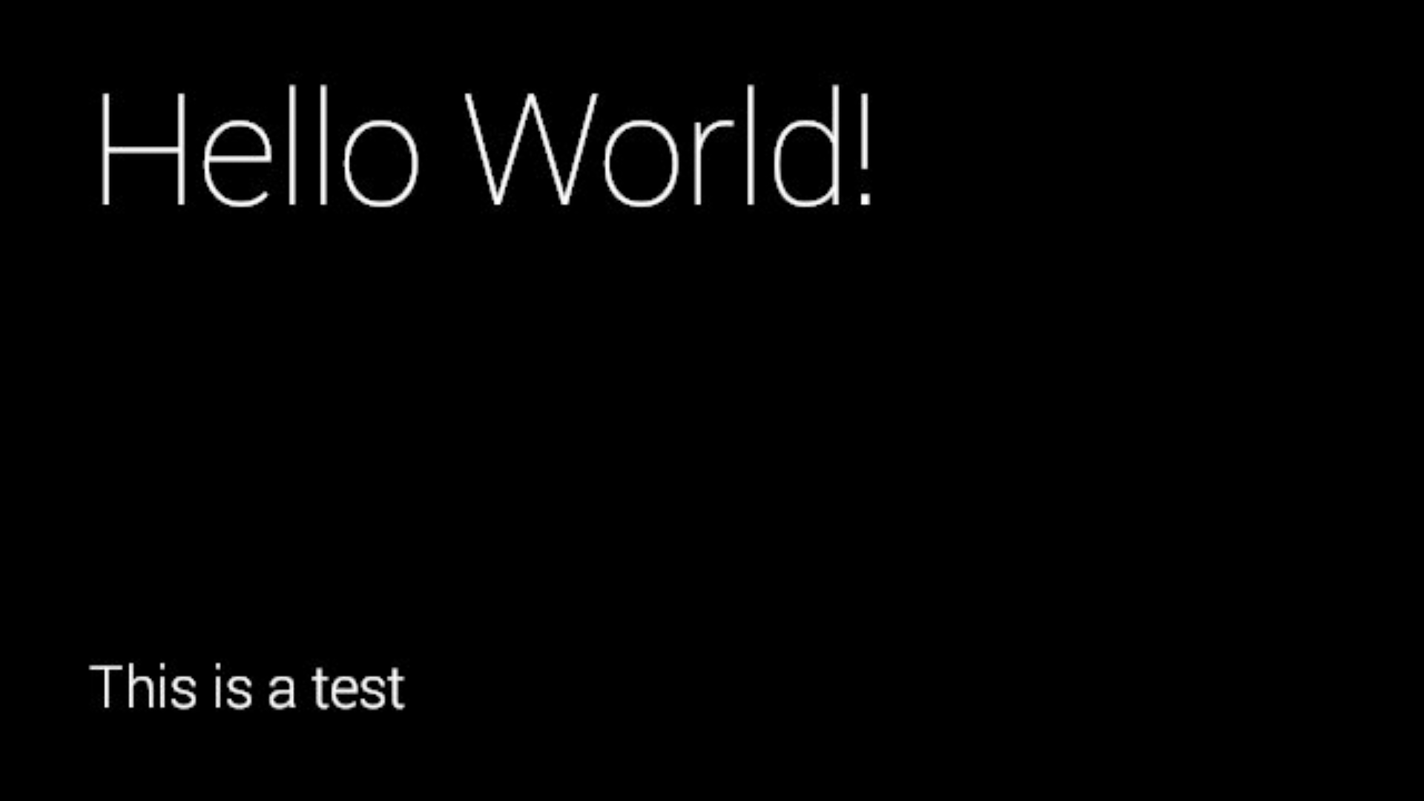
Show pictures  -Same instructions as ‘show a card with text’  -Update Code to add a picture and set a FULL image layout  -Add a picture in the drawable-hdpi,drawable-xxhdpi,drawable-xhdpi,drawable-mdpi in the res folder | See HelloWorldPicture  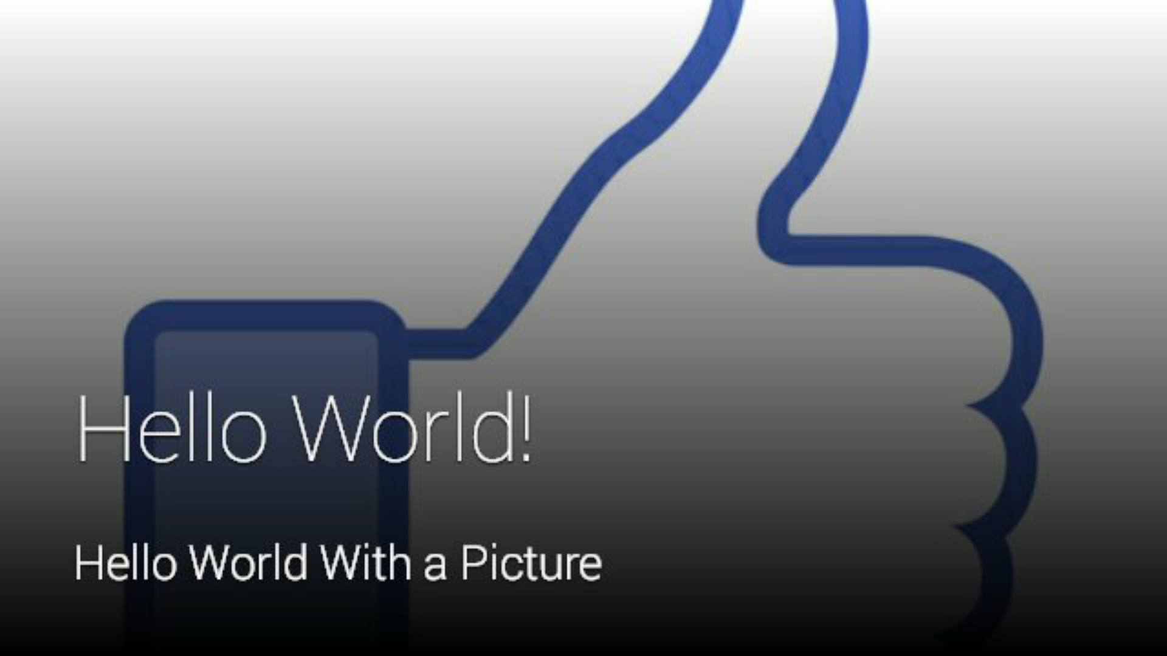
Show videos
Build a menu
...
Control/sensor related
Touch pad
Microphone, voice input
ACCELEROMETER
GRAVITY
GYROSCOPE
LIGHT
LINEAR_ACCELERATION
MAGNETIC_FIELD
ORIENTATION (deprecated)
ROTATION_VECTOR
Camera
Blue tooth
Wifi

Questions need answers
Is there a way to build a glass emulator using virtual devices/virtual Android phones, like the ones used in ADK?
Currently it seems not possible.

